**User Manual for SLC Tool**

* User needs to download all the files from the URL.

All Eclipse projects at first needs to be imported in some existing or new workspace (refer Figure 1). The CompliantFSM folder needs to be downloaded as well which provides supporting files for the framework (refer Figure 2) and save it in c:/ drive.

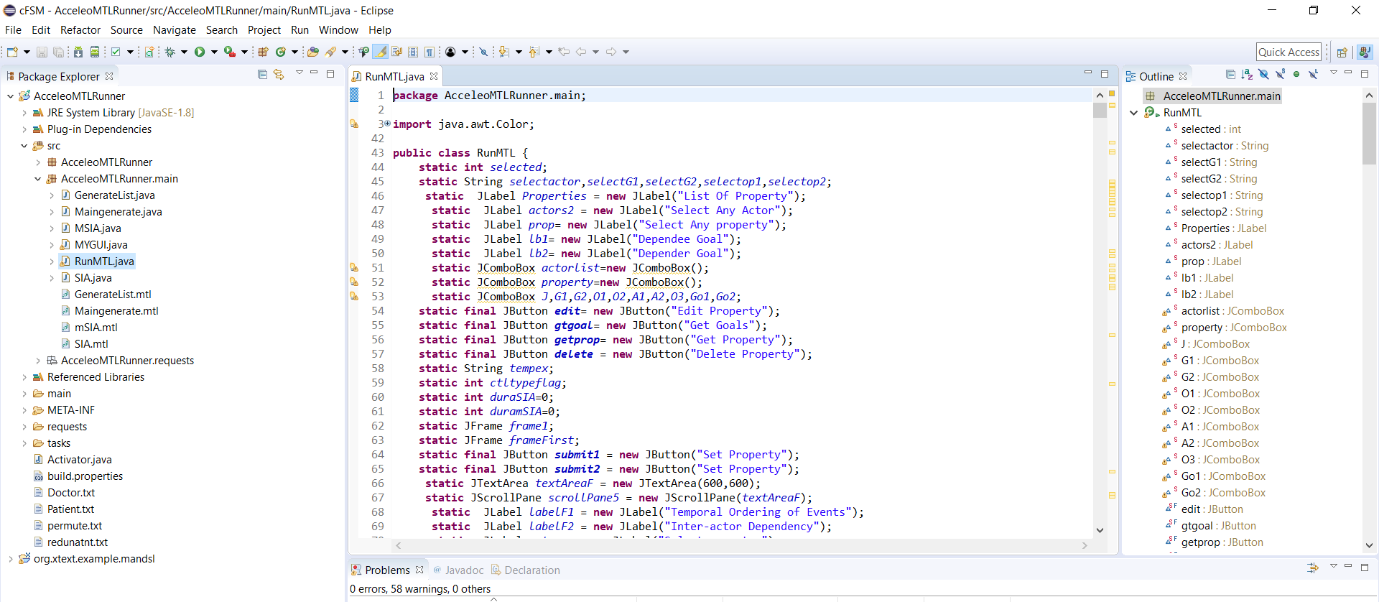

Figure -1

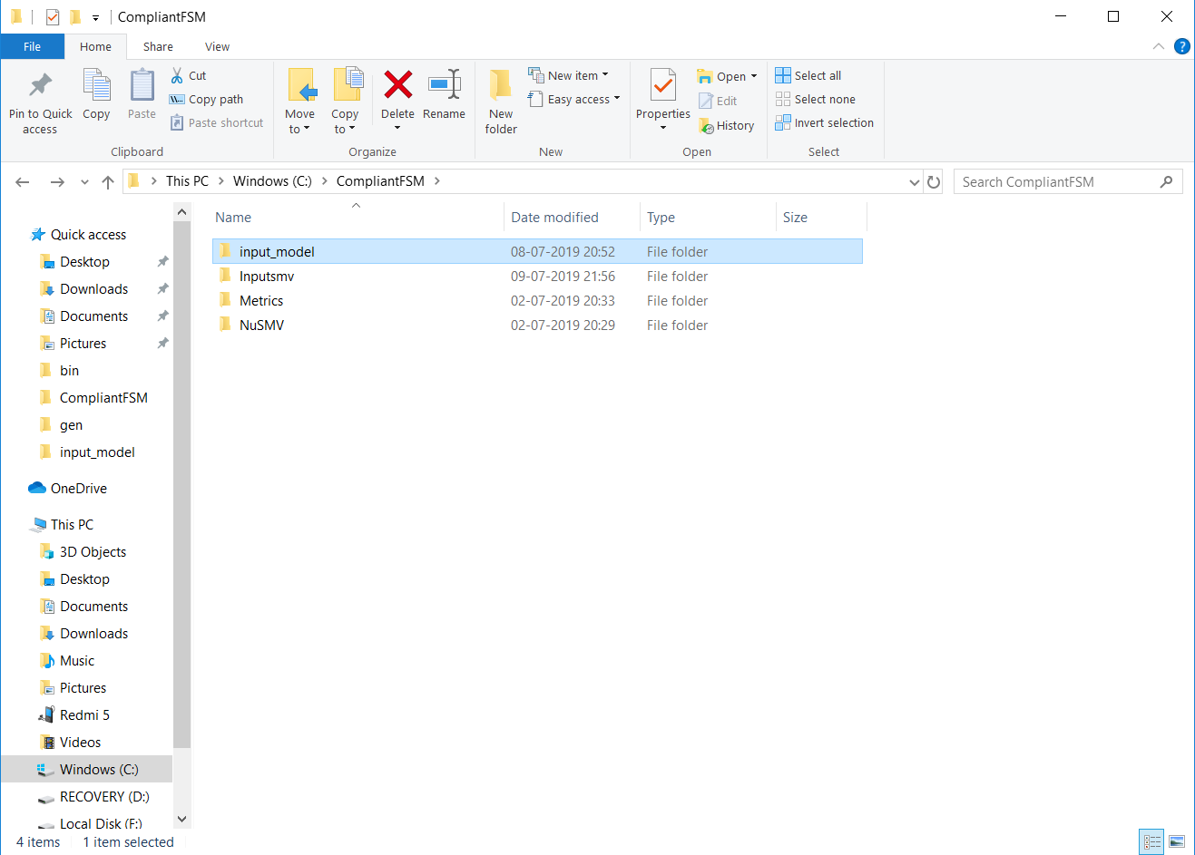

Figure -2

* Steps of using the tool:-
* **Step 1:**

Execute RunMTL.Java file from AcceleoMTLRunner project. SLC Tool- Input initialization frame appears (refer Figure 3).

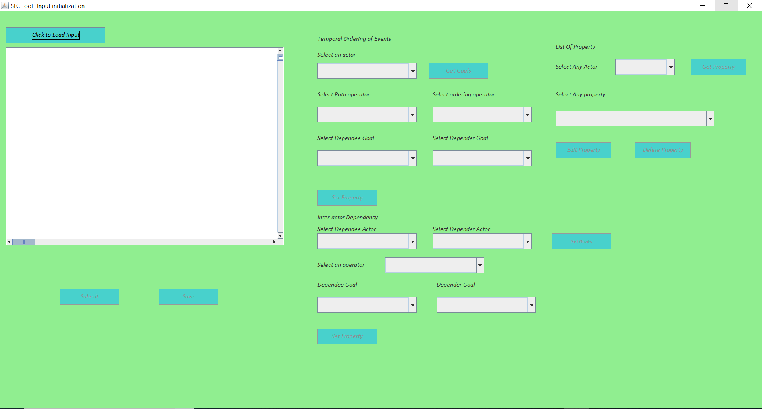

Figure 3

* **Step 2:**

Select an input file by clicking on “*Click to Load Input*“ button (refer Figure 4). After loading input goal model all other buttons get activated (refer Figure 4).

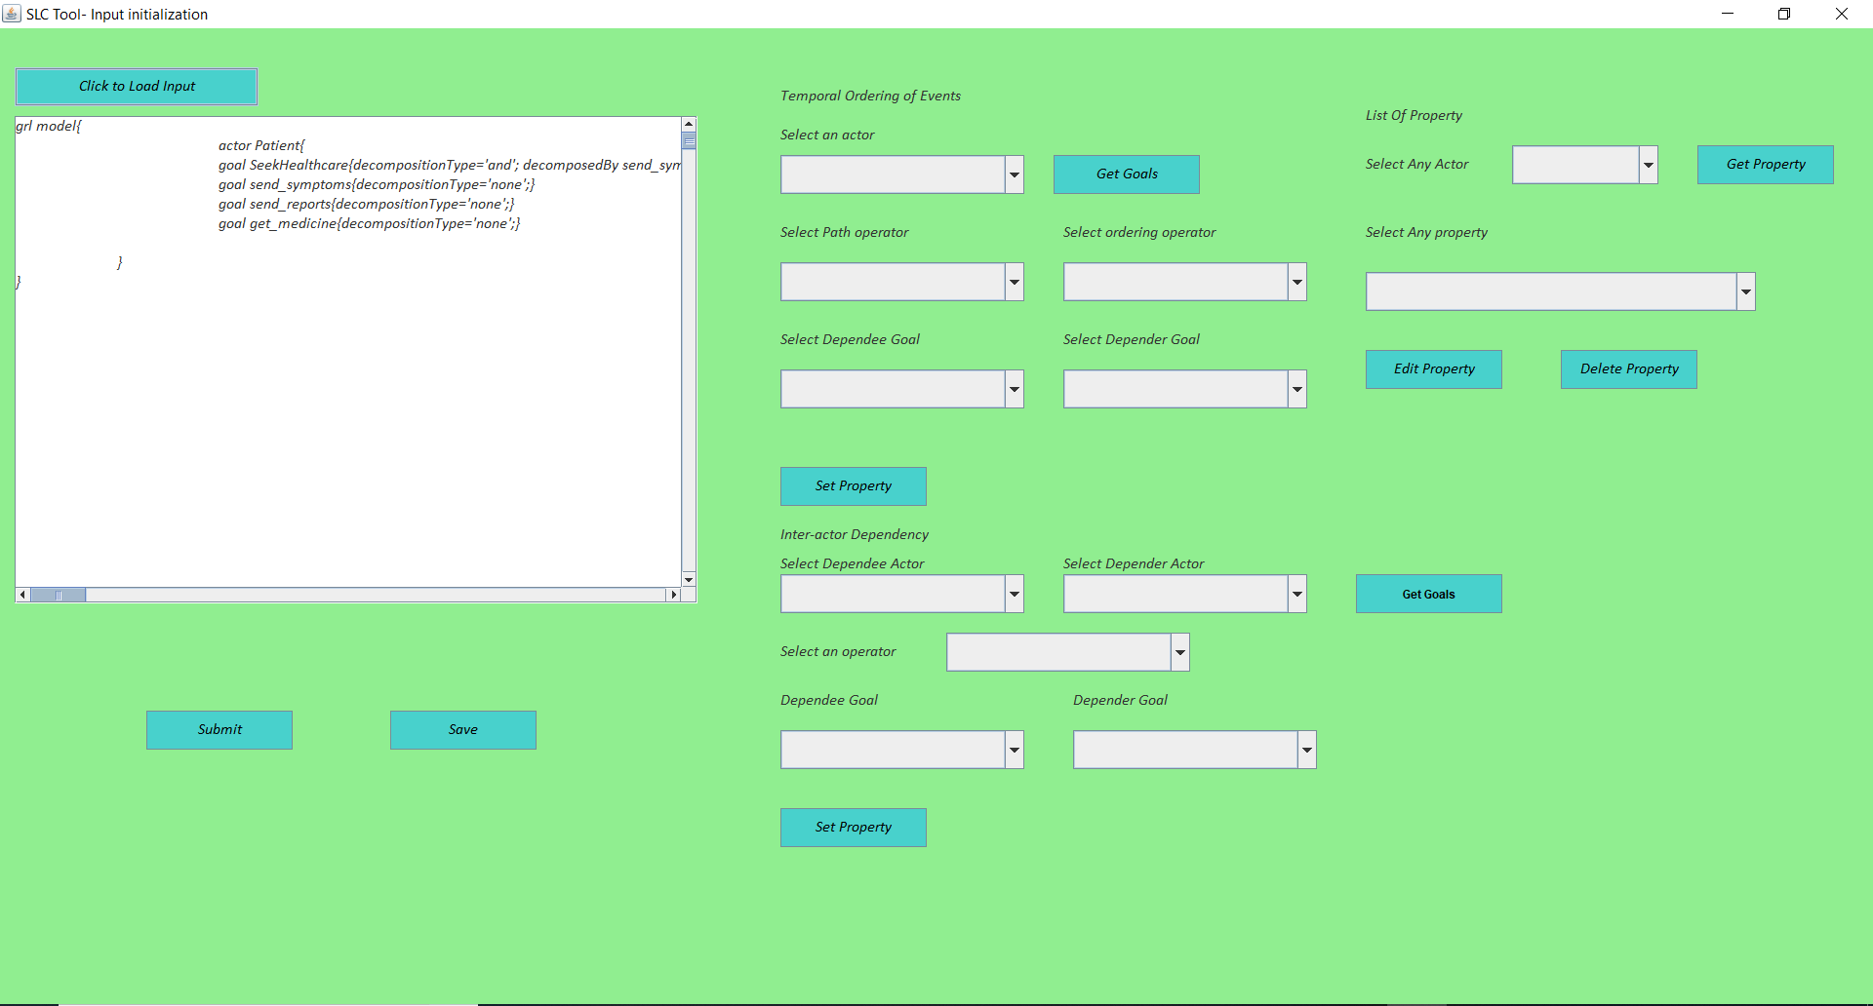

Figure 4

* **Step 3:**

Select an actor from “*Select an actor”*  drop down menu and click on *“Get Goals”* button. The goals of the selected actor appear in the drop down menus – “*Select Dependee goal*” and “*Select Depender goal*”.

* **Step 4:**

Select a path operator (“*Select path operator”)*, a temporal ordering (“*Select ordering operator”)* operator and dependee (“*Select Dependee goal”)* and depender goal *(“Select Depender goal”)*. Click on “*Set Property”* button. The property gets saved in a temporary file (refer Figure 5).

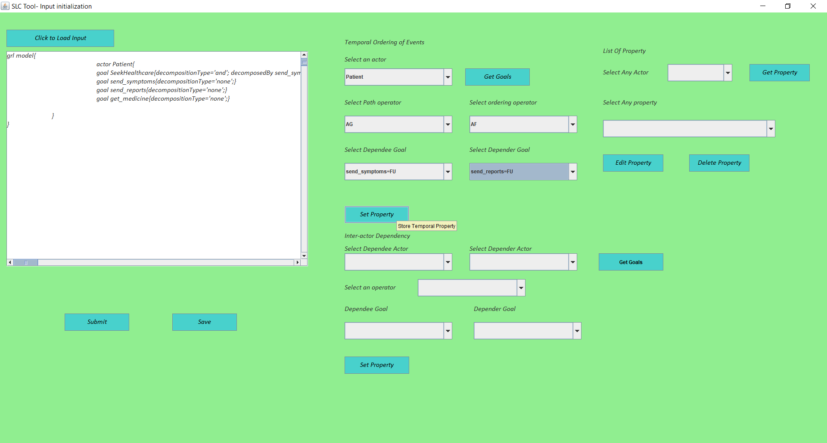

Figure 5

* **Step 5:**

Click on “*Save*” button to see the updated input (refer Figure 6).

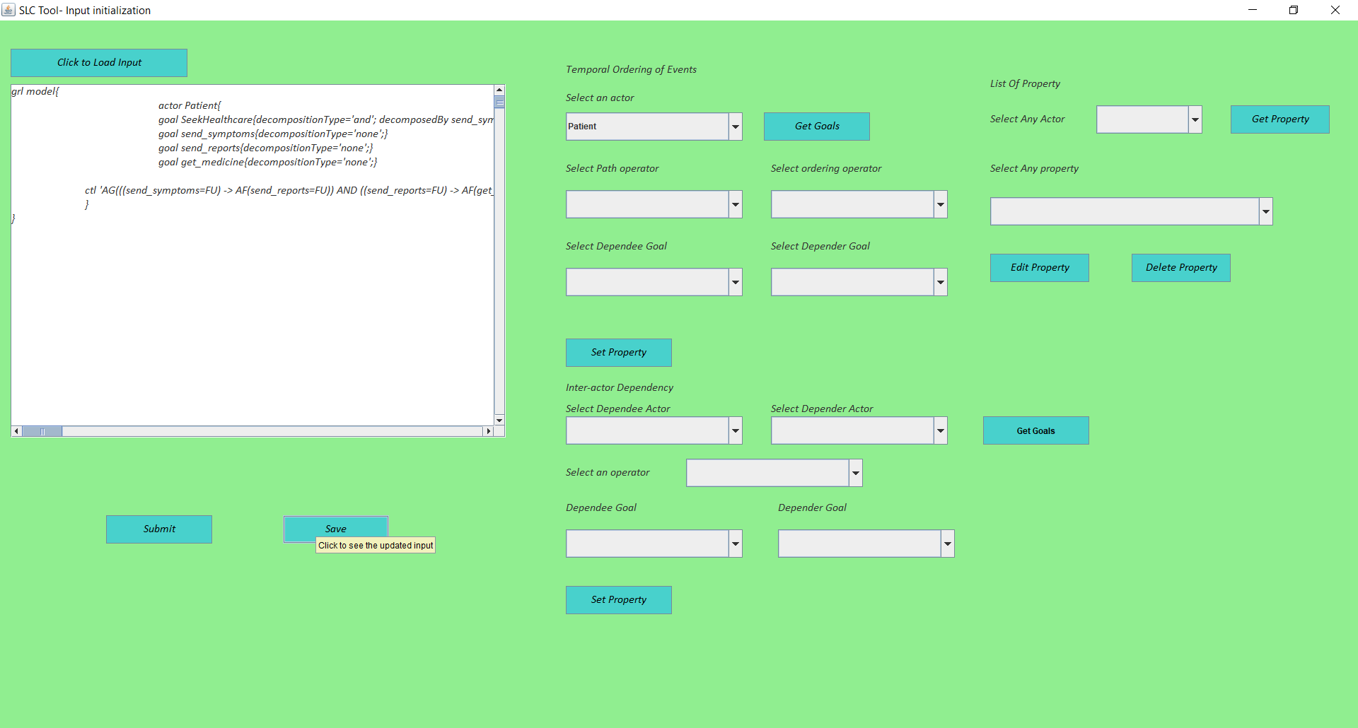

Figure 6

* **Step 6:**

**Modifying property**

In “*List of Property*” panel select any actor using “*Select Any Actor”* drop down menu and click on “*Get Property”* button. The saved CTL property appears in the drop-down menu (“*Select Any property”)*. Select any property and click on “*edit*” or “*delete*” button (refer Figure 7).

On clicking “*edit*” button the selected property gets mapped into initial property specifying boxes on immediate left panel. Modify the property and again click on “*Set Property”* button (refer Figure 8). 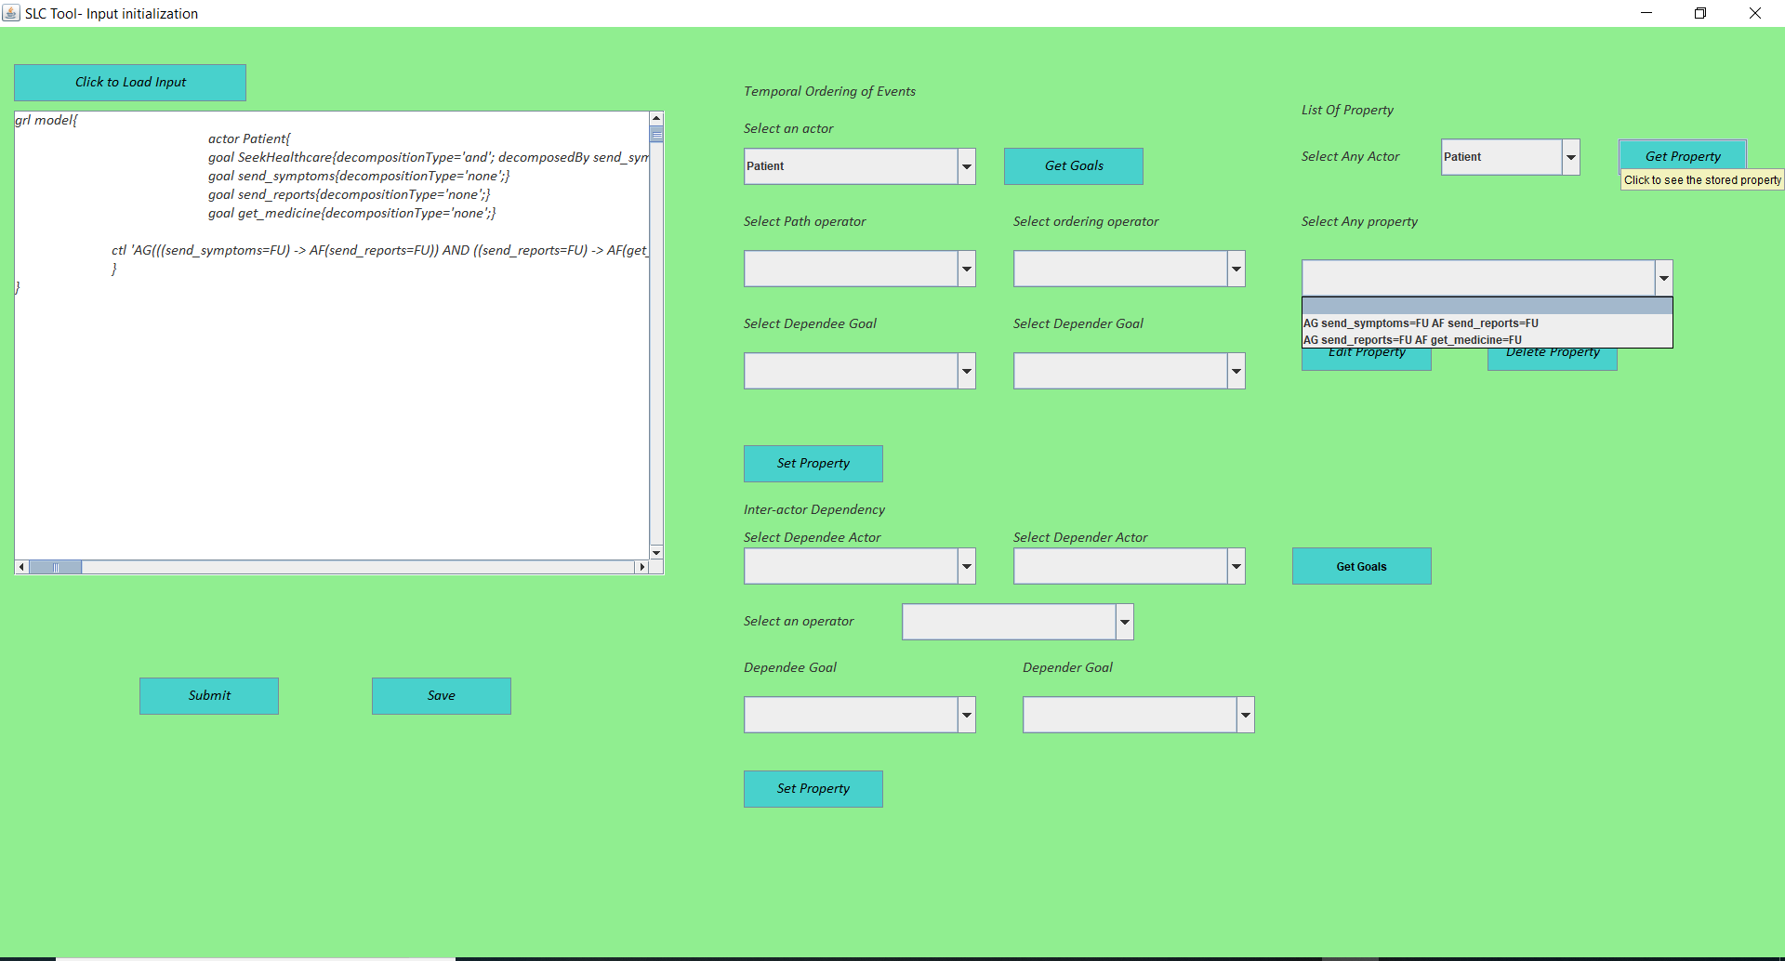

Figure 7

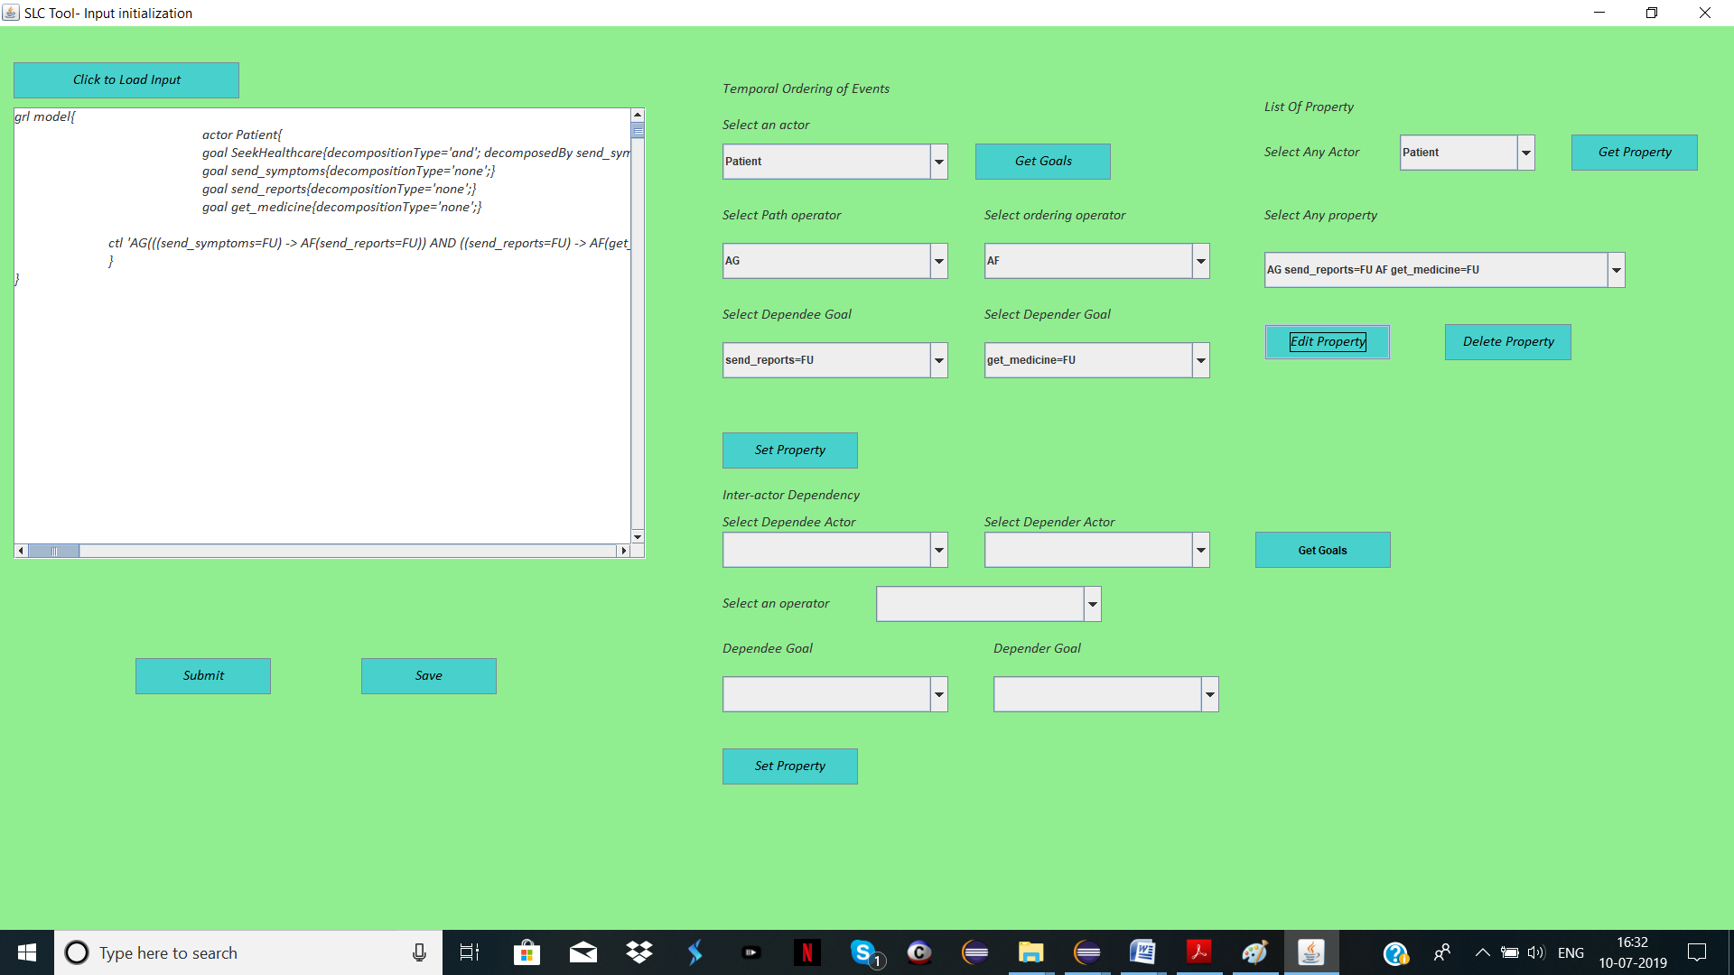

Figure 8

* **Step 7:**

**Setting Inter-Actor property:**

Select dependee (“*Select Dependee Actor*”) and depender (“*Select Depender Actor*”) actor, a temporal operator (“*Select an operator*”), and the goals (“*Dependee goal*” and “*Depender Goal*”). Then Click on “*Set Property”* button below.

* **Step 8:**

Click on “*submit”* button to generate compliant finite state model. The SLC Tool- FSM Generation frame appears. The “*INPUT PANEL”* consists of the input selected and modified in the previous frame (refer Figure 9).

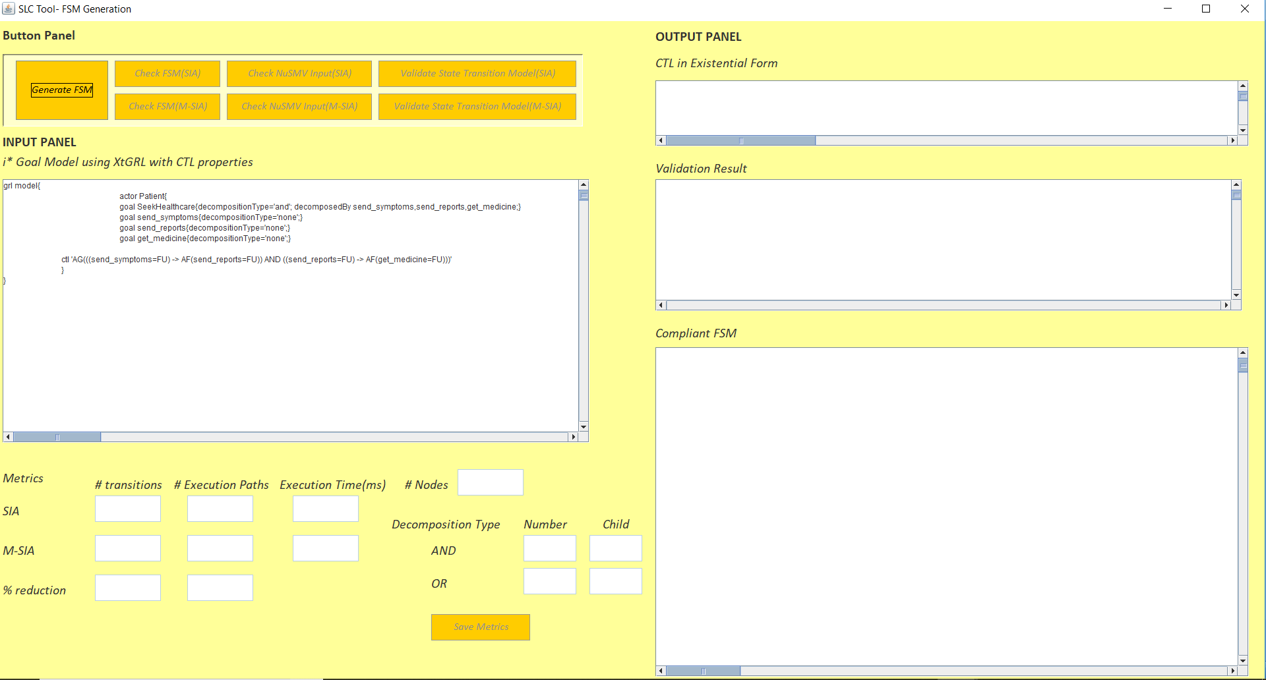

Figure 9

* **Step 9:**

Click on “*Generate FSM”* button to initiate FSM generation. After FSM generation is complete all other buttons in the button panel gets activated. The different metrics that provide a comparison between two algorithms appear in the left-bottom panel (refer Figure 10).

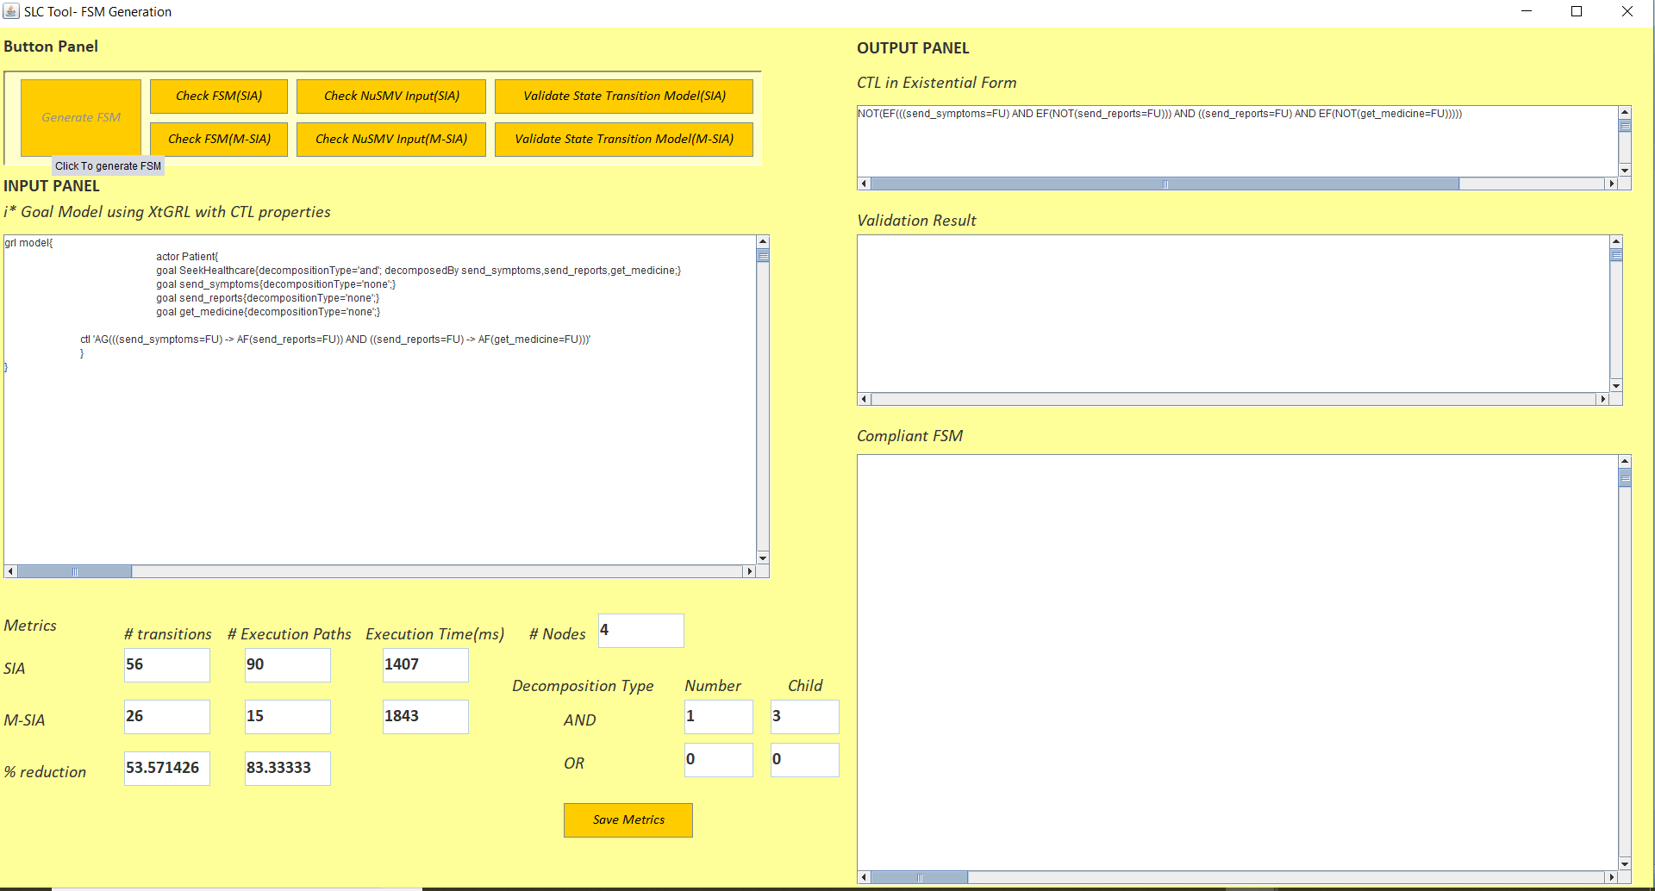

Figure 10

* **Step 10:**

Click on “*Check FSM(SIA)”* or “*Check NuSMV Input(SIA)”* button to check the finite state machine and NuSMV input generated using SIA (refer Figure 11).

* **Step 11:**

Click on “*Check FSM(M-SIA)”* or “*Check NuSMV Input(M-SIA)”* button to check the finite state machine and NuSMV input generated using M- SIA.

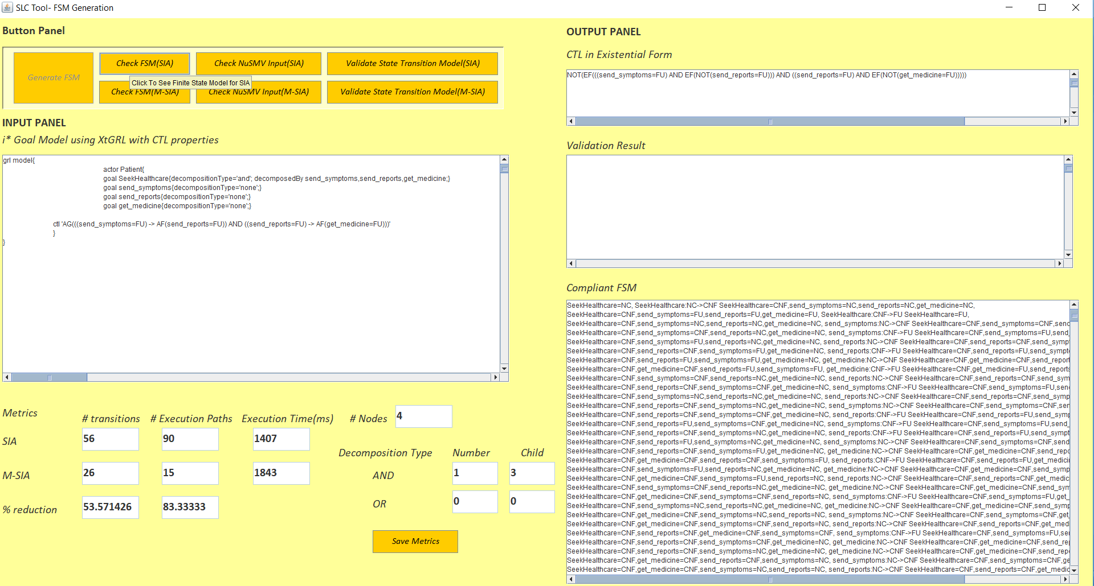

Figure 11

* **Step 12:**

Click on “*Validate State Transition Model(SIA)”* to peform model checking for FSM generated using SIA with the given CTL properties (refer Figure 12).

* **Step 13:**

Click on “*Validate State Transition Model(M-SIA)”* to peform model checking for FSM generated using SIA with the given CTL properties.

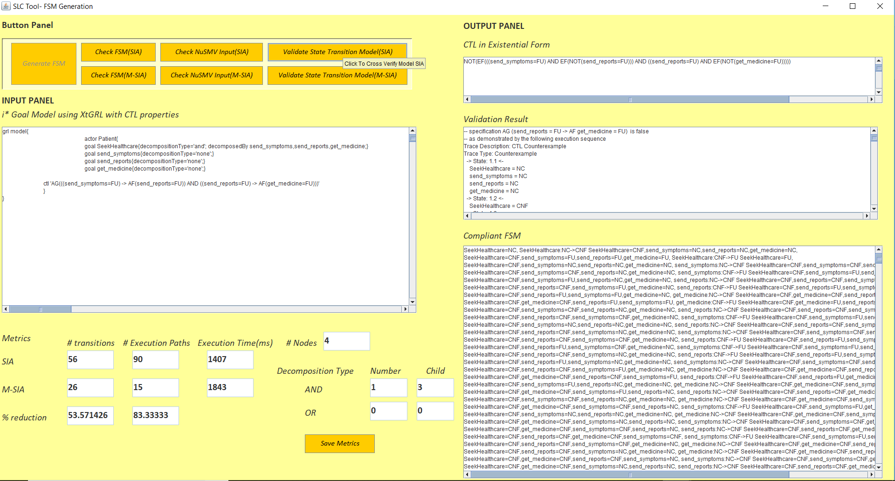

Figure 12